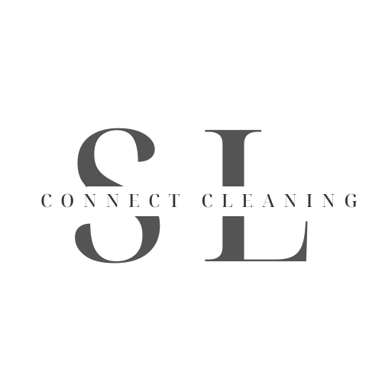

**Privacy Policy for SL Connect Cleaning**

**2025**

At SL Connect Cleaning, we are committed to protecting your privacy and ensuring that your personal information is handled in a safe and responsible manner. This Privacy Policy outlines the types of personal information we collect, how we use it, and your rights regarding that information.

### **1. Information We Collect**

We collect the following types of personal information when you interact with our services:

* **Personal Identification Information**: This may include your name, phone number, email address, and mailing address.
* **Payment Information**: If you make a payment for our services, we may collect your payment details, such as credit card or bank account information.
* **Service Information**: We collect information related to the services you request, including the location of the property being cleaned and special instructions.

### **2. How We Use Your Information**

We use your personal information for the following purposes:

* To provide, personalize, and improve our cleaning services.
* To communicate with you regarding your service requests, appointments, and follow-up.
* To process payments and handle billing-related inquiries.
* To send you promotional emails, offers, or updates, if you have consented to receive such communications.
* To comply with legal obligations or protect our rights and interests.

### **3. How We Protect Your Information**

We take reasonable precautions to safeguard your personal information. This includes implementing security measures such as encryption and restricting access to your data to authorized personnel only.

However, no method of transmission over the internet or method of electronic storage is 100% secure. While we strive to use commercially acceptable means to protect your personal information, we cannot guarantee its absolute security.

### **4. Sharing Your Information**

We do not sell or rent your personal information to third parties. However, we may share your information in the following circumstances:

* **Service Providers**: We may share your information with trusted third-party service providers who assist us in delivering our services (e.g., payment processors, marketing partners). These providers are contractually obligated to keep your information secure and to use it only for the purposes for which it was shared.
* **Legal Compliance**: We may disclose your information if required by law, regulation, or legal process, or to protect the rights, property, and safety of [Your Cleaning Business Name], our customers, or others.

### **5. Your Rights**

You have the following rights regarding your personal data:

* **Access**: You can request to see the personal information we hold about you.
* **Correction**: You can request that we correct or update your personal information.
* **Deletion**: You can request that we delete your personal information, subject to legal obligations and business needs.
* **Opt-out**: You can opt out of receiving marketing communications at any time by clicking the “unsubscribe” link in our emails or contacting us directly.

To exercise any of these rights, please contact us at [Your Contact Email or Phone Number].

### **6. Cookies and Tracking Technologies**

We may use cookies and similar tracking technologies to enhance your experience on our website. Cookies are small files that are stored on your device and help us analyze web traffic, remember user preferences, and improve our website’s functionality.

You can control cookies through your browser settings, but note that disabling cookies may affect your ability to use certain features of our site.

### **7. Third-Party Links**

Our website may contain links to third-party websites. We are not responsible for the content or privacy practices of these websites. We encourage you to read the privacy policies of any third-party sites you visit.

### **8. Children’s Privacy**

Our services are not intended for individuals under the age of 18. We do not knowingly collect personal information from children under 18. If you believe we have inadvertently collected such information, please contact us immediately.

### **9. Changes to This Privacy Policy**

We reserve the right to update or modify this Privacy Policy at any time. Any changes will be posted on this page with an updated “Effective Date.” We encourage you to review this Privacy Policy periodically to stay informed about how we are protecting your information.

### **10. Contact Us**

If you have any questions or concerns about this Privacy Policy or how we handle your personal information, please contact us at:

SL Connect Cleaning  
 [support@slconnectcleaning.com](mailto:support@slconnectcleaning.com)

East Stroudsburg, PA, 18301